Nama: Fitri Noor Apsari

Kelas B

**TEMPLATE SUMMARIZE**

**System:** Summarize content you are provided with for a second-grade student.

**User:** Jupiter is the fifth planet from the Sun and the largest in the Solar System. It is a gas giant with a mass one-thousandth that of the Sun, but two-and-a-half times that of all the other planets in the Solar System combined. Jupiter is one of the brightest objects visible to the naked eye in the night sky, and has been known to ancient civilizations since before recorded history. It is named after the Roman god Jupiter.[19] When viewed from Earth, Jupiter can be bright enough for its reflected light to cast visible shadows,[20] and is on average the third-brightest natural object in the night sky after the Moon and Venus.

**Assistant:** Jupiter is a really big planet in our Solar System. It is the fifth planet from the Sun and it is the largest planet. It is called a gas giant because it is made mostly of gas. Jupiter is much smaller than the Sun, but it is bigger than all the other planets combined. It is very bright and can be seen in the night sky without a telescope. People have known about Jupiter for a very long time, even before they started writing things down. It is named after a god from ancient Rome. When we look at Jupiter from Earth, it can be so bright that it can make shadows. It is usually the third-brightest thing we can see in the night sky, after the Moon and Venus.

**Output yang dihasilkan:** Jupiter is a big planet that is the fifth one away from the Sun. It is the largest planet in our Solar System and is very bright at night. People have known about Jupiter for a long time and it is named after a Roman god. When we look at Jupiter from Earth, it can be so bright that it can even make shadows. It is usually the third-brightest thing we can see in the night sky, after the Moon and Venus.

Mode: chat

Model: GPT-3.5-turbo

Temperature: 0

Maximum length: 1024

Top p: 1

Frequency finallty: 0

Presence penalty: 0

**Hasil Screenshots:**

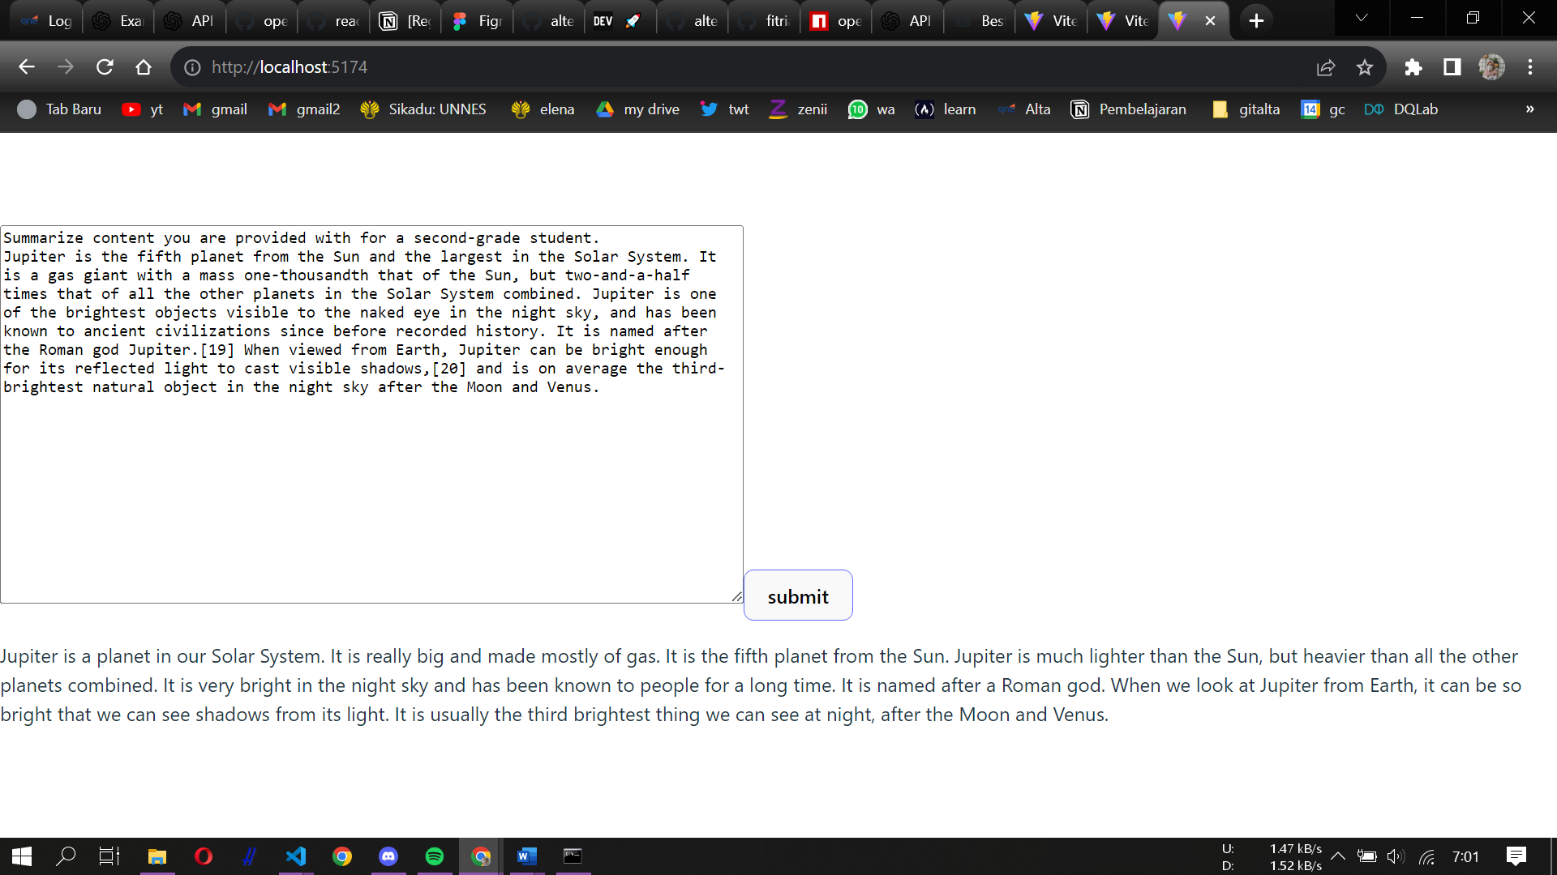

**System:** Summarize content you are provided with for a second-grade student.

**User:** Jupiter is the fifth planet from the Sun and the largest in the Solar System. It is a gas giant with a mass one-thousandth that of the Sun, but two-and-a-half times that of all the other planets in the Solar System combined. Jupiter is one of the brightest objects visible to the naked eye in the night sky, and has been known to ancient civilizations since before recorded history. It is named after the Roman god Jupiter.[19] When viewed from Earth, Jupiter can be bright enough for its reflected light to cast visible shadows,[20] and is on average the third-brightest natural object in the night sky after the Moon and Venus.

**Assistant:** Jupiter is a really big planet in our Solar System. It is the fifth planet from the Sun and it is the largest planet. It is called a gas giant because it is made mostly of gas. Jupiter can be seen in the night sky without a telescope and it looks very bright! People have known about Jupiter for a long time, even before they started writing things down. It got its name from an ancient Roman god named Jupiter.

When we look at Jupiter from Earth, it can be so bright that it makes shadows! That's pretty cool! In fact, most of the time when we look up at night, only the Moon and Venus are brighter than Jupiter.

So remember, if you ever see something really bright in the sky at night that isn't as big as our Sun or Moon - chances are you're looking at mighty ol' Jupiter!

Mode: chat

Model: GPT-3.5-turbo

Temperature: 0

Maximum length: 1024

Top p: 1

Frequency finallty: 2

Presence penalty: 0

**Hasil Screenshots:**

**System:** Summarize content you are provided with for a second-grade student.

**User:** Jupiter is the fifth planet from the Sun and the largest in the Solar System. It is a gas giant with a mass one-thousandth that of the Sun, but two-and-a-half times that of all the other planets in the Solar System combined. Jupiter is one of the brightest objects visible to the naked eye in the night sky, and has been known to ancient civilizations since before recorded history. It is named after the Roman god Jupiter.[19] When viewed from Earth, Jupiter can be bright enough for its reflected light to cast visible shadows,[20] and is on average the third-brightest natural object in the night sky after the Moon and Venus.

**Assistant:** Jupiter is a big planet in our Solar System. It is the fifth planet from the Sun and it is the biggest one. It is called a gas giant because it is made mostly of gas. Jupiter can be seen in the night sky without a telescope and it looks very bright! People have known about Jupiter for a long time, even before they started writing things down. It got its name from an ancient Roman god named Jupiter.

When we look at Jupiter from Earth, it can be so bright that it makes shadows! That's pretty cool! In fact, most of the time when we look up at night, only the Moon and Venus are brighter than Jupiter.

So remember, if you ever see something really bright in the sky at night that isn't as big as our Sun or Moon - chances are you're looking at mighty ol' Jupiter!

Mode: chat

Model: GPT-3.5-turbo

Temperature: 0

Maximum length: 1024

Top p: 1

Frequency finallty: 1

Presence penalty: 0.5

**Hasil Screenshots:**

**TEMPELATE GRAMMAR CORRECTION**

**System:** You will be provided with statements, and your task is to convert them to standard English.

**User:** She no went to the market.

**Assistant:** She did not go to the market.

Mode: chat

Model: GPT-3.5-turbo

Temperature: 0

Maximum length: 256

Top p: 1

Frequency finallty: 0

Presence penalty: 0

**Hasil screenshots:**

